DBMS - Mini Project

Title of the Project:

Club Membership Management

Submitted By:

Name: BASAVAPRABHU G KIRAGI

SRN: PES1UG20CS631

V Semester Section : K

Short Description and Scope of the Project:

A **D**ata **B**ase **M**anagement **S**ystem is a system software for easy, efficient and reliable data processing and management. It can be used for:

* Creation of a database.
* Retrieval of information from the database.
* Updating the database.
* Managing a database.

This is a simple database managements project made using mysql, streamlit, python.

It facilitates management of user database information like customer details, employee’s details, and club details. The features include creation /insertions, deletion, viewing and updating of database through user interactive interface.

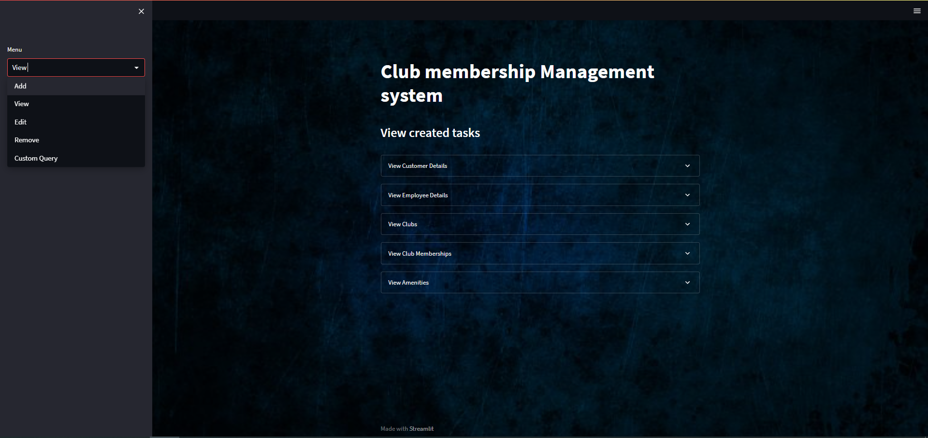

ER Diagram:

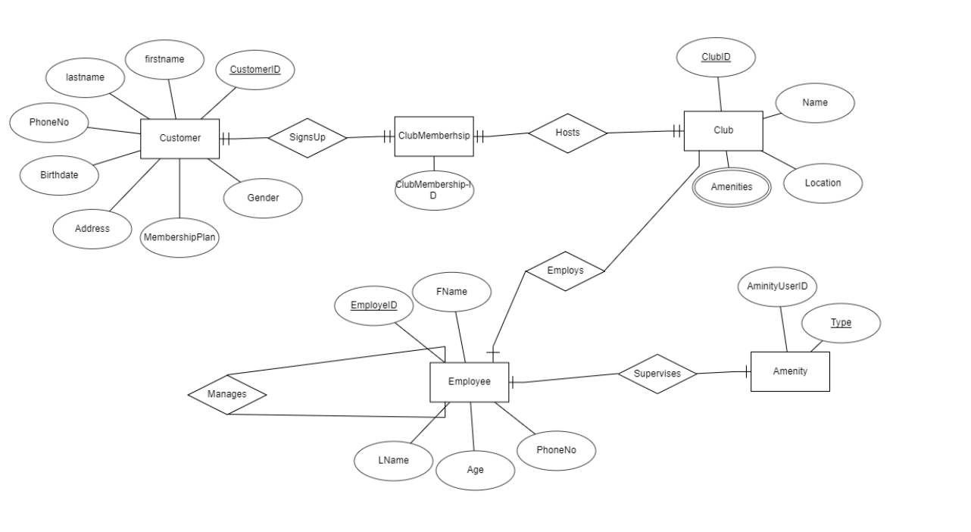

Relational Schema:

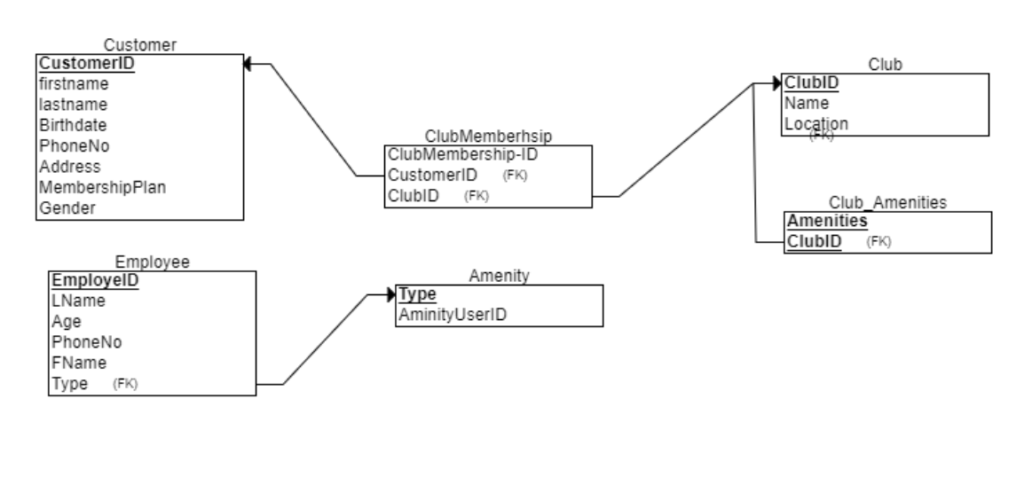

DDL statements - Building the database

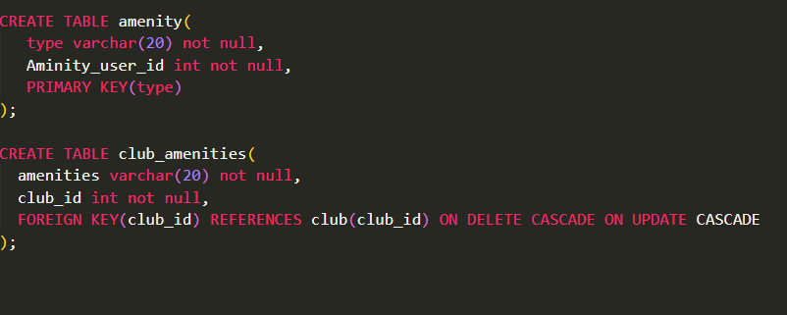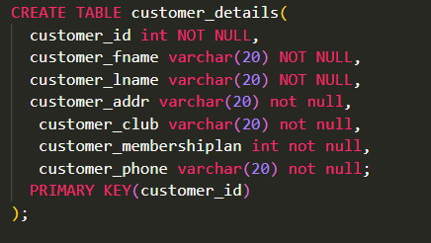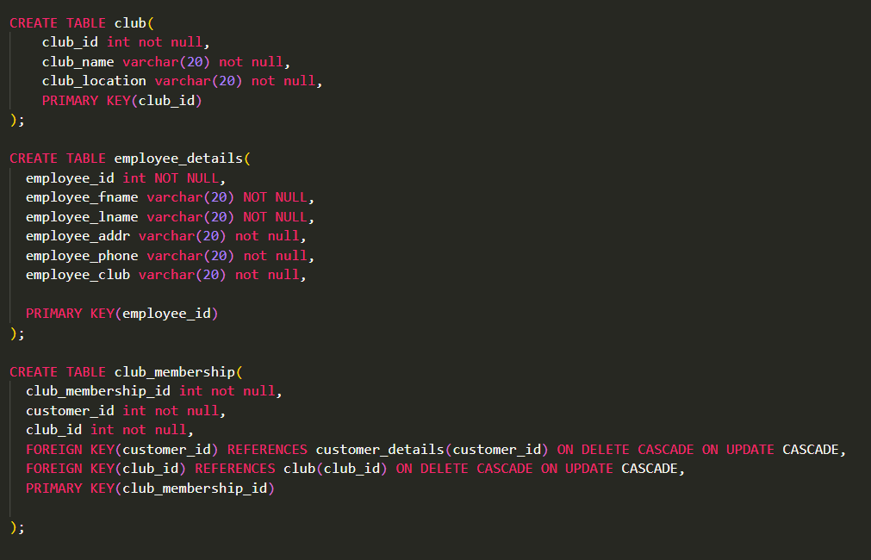

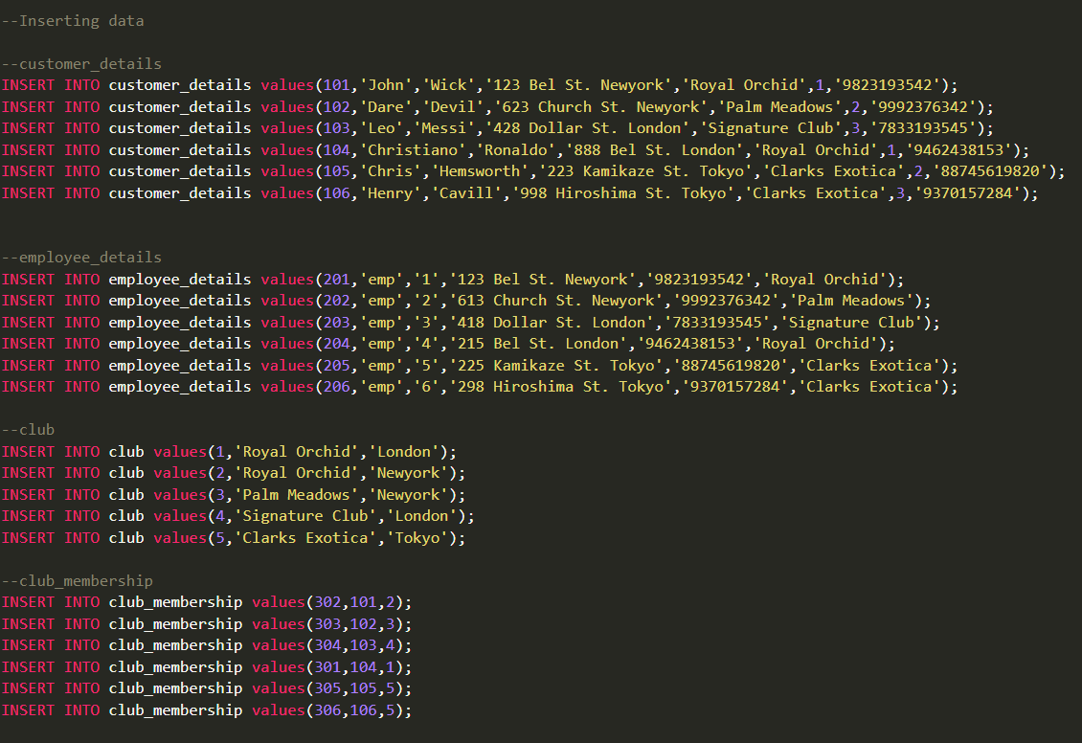Populating the Database:



Join Queries:

1. Joining all club membership with the club using club_id as key:

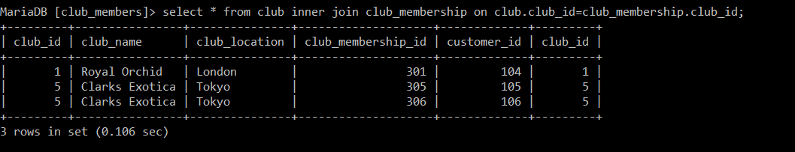

1. Joining Customer_details and club tables using club_name;

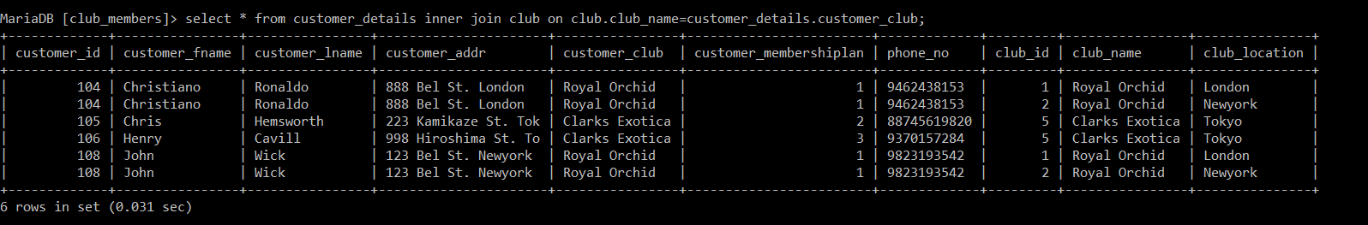

1. Creating temp view and then joining using club id

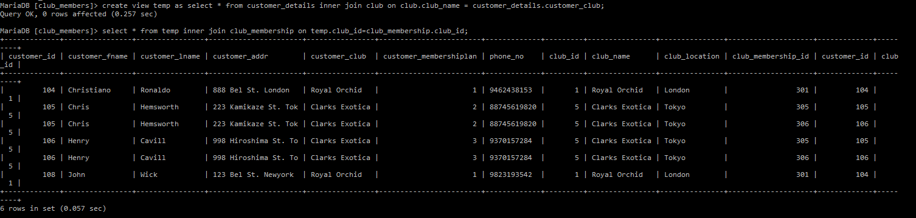

Aggregate Functions:

1. Finding most frequent membership plan bought:

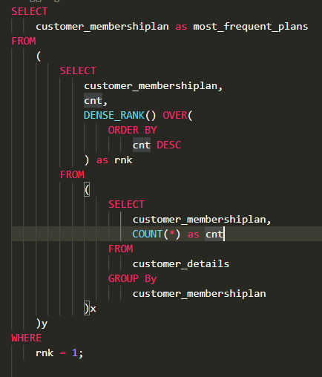

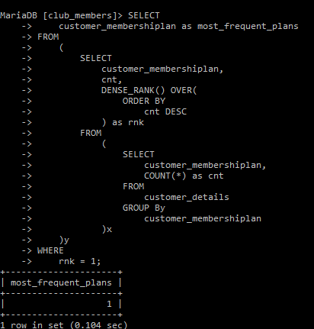

1. Counting the number of customers in each club:

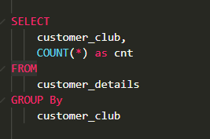

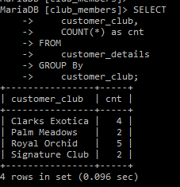

Set Operations:

1. Union:

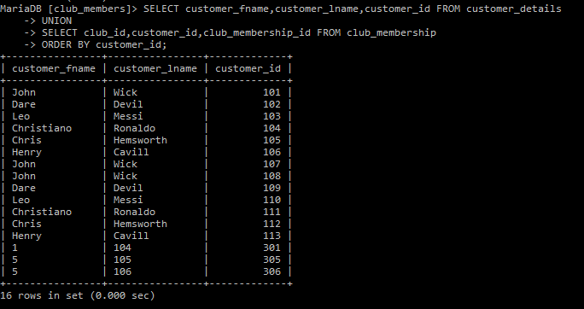

1. Intersection:

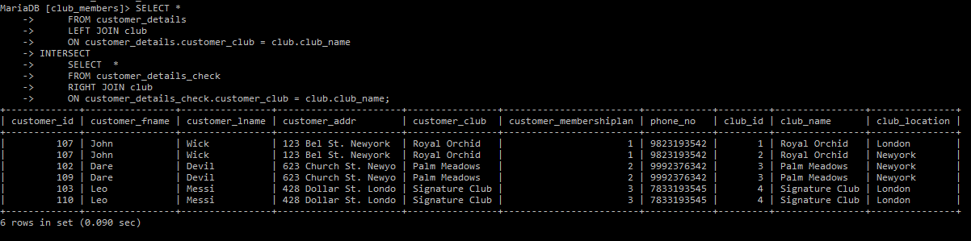

Functions and Triggers:

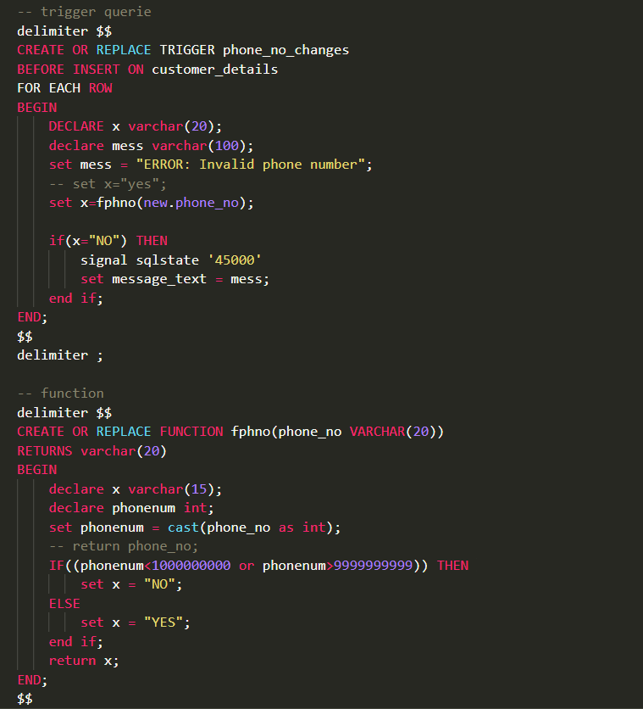

1. Trigger to check the mobile number before insert:

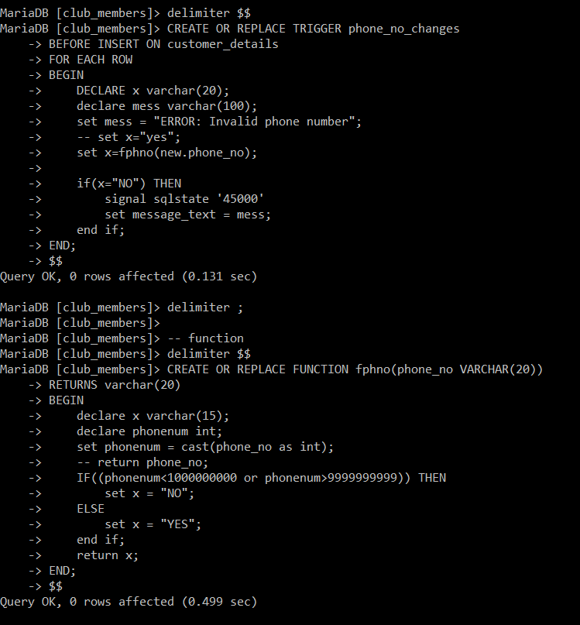

Valid:

Invalid:

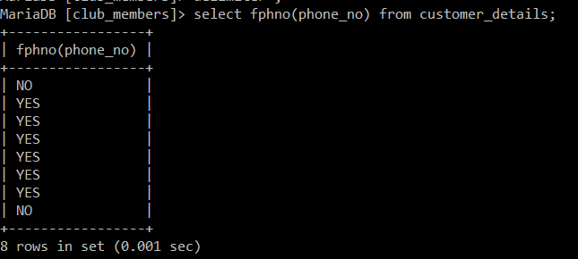

Developing a Frontend:

1. Front Page:

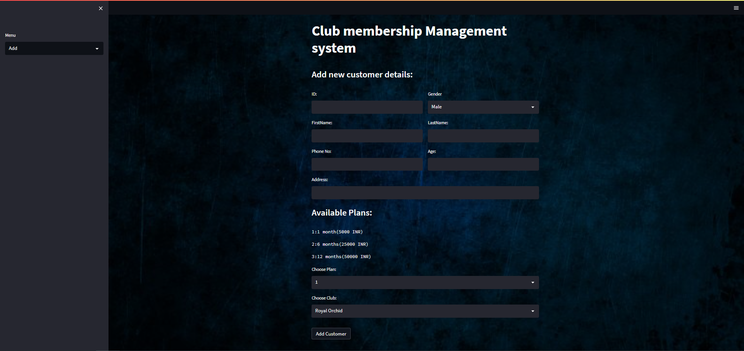

1. View : (users)

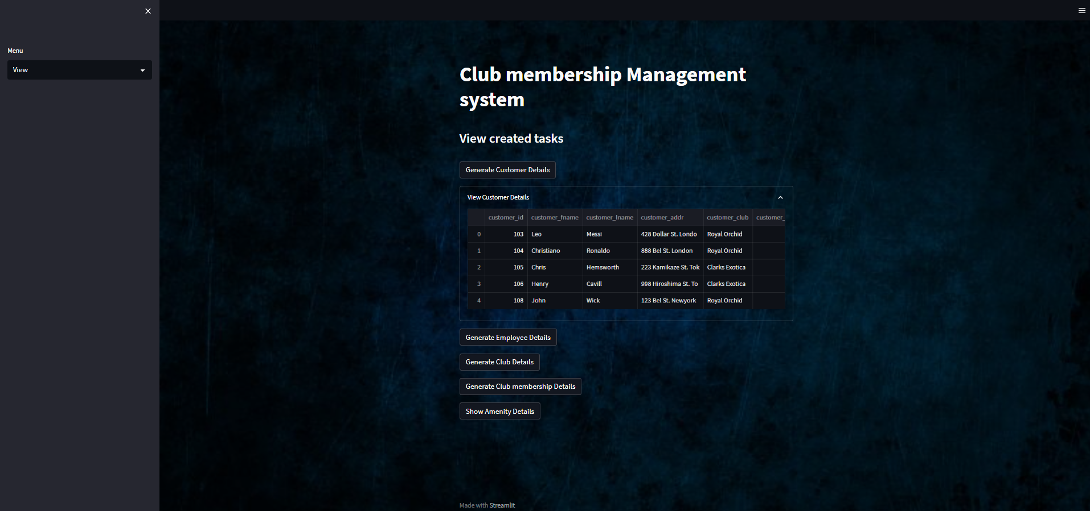

1. Add and Delete: (add or remove customers)

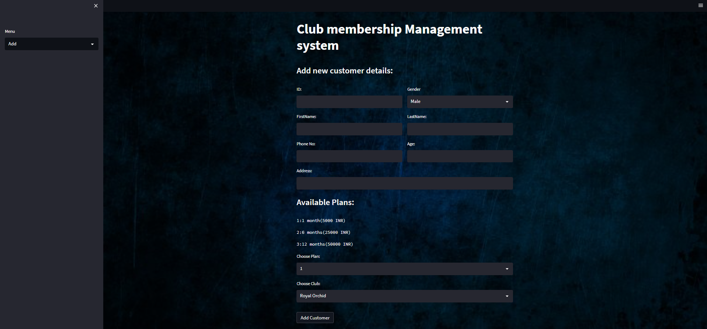

1. Removing /Deleting

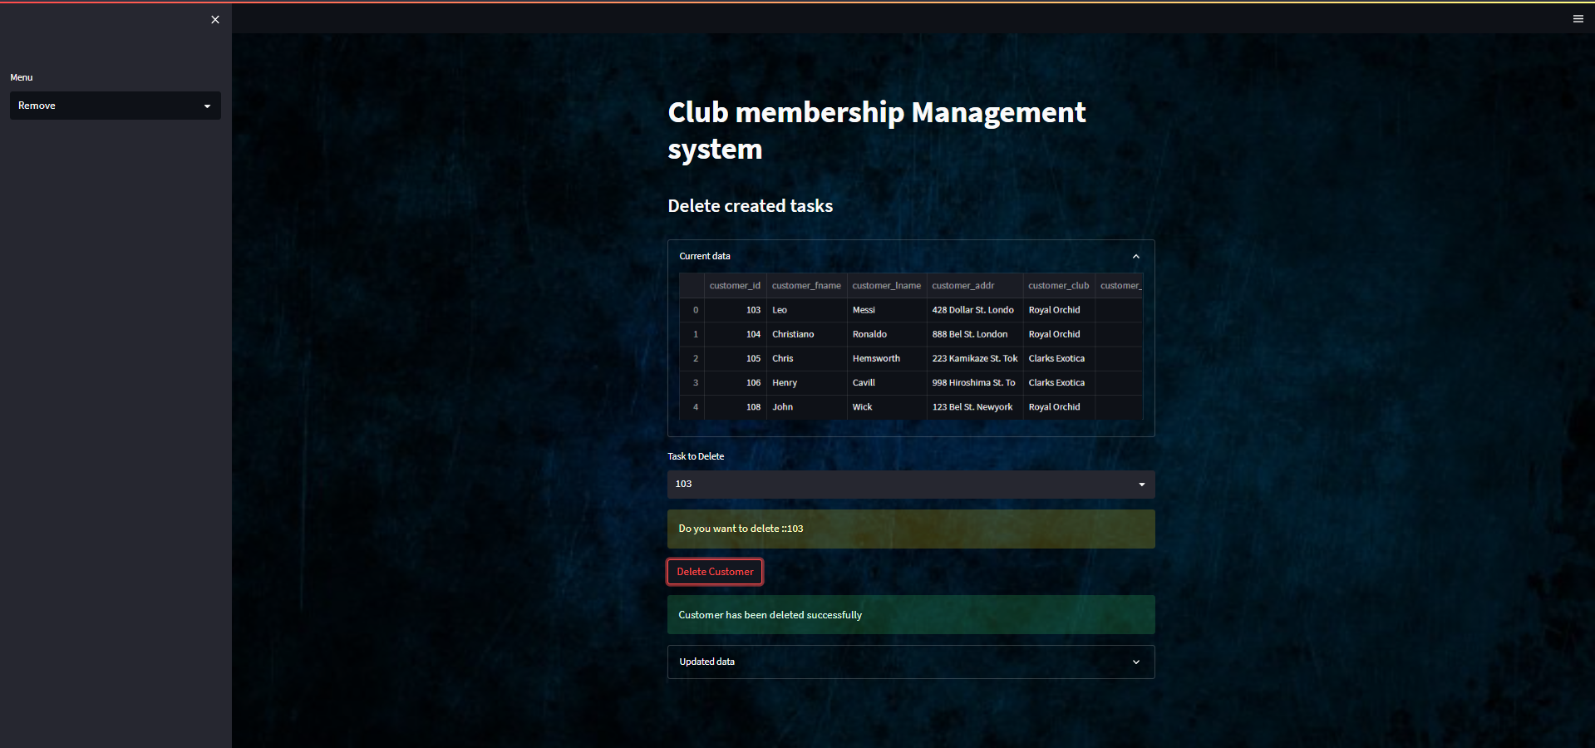

1. Edit/Update:

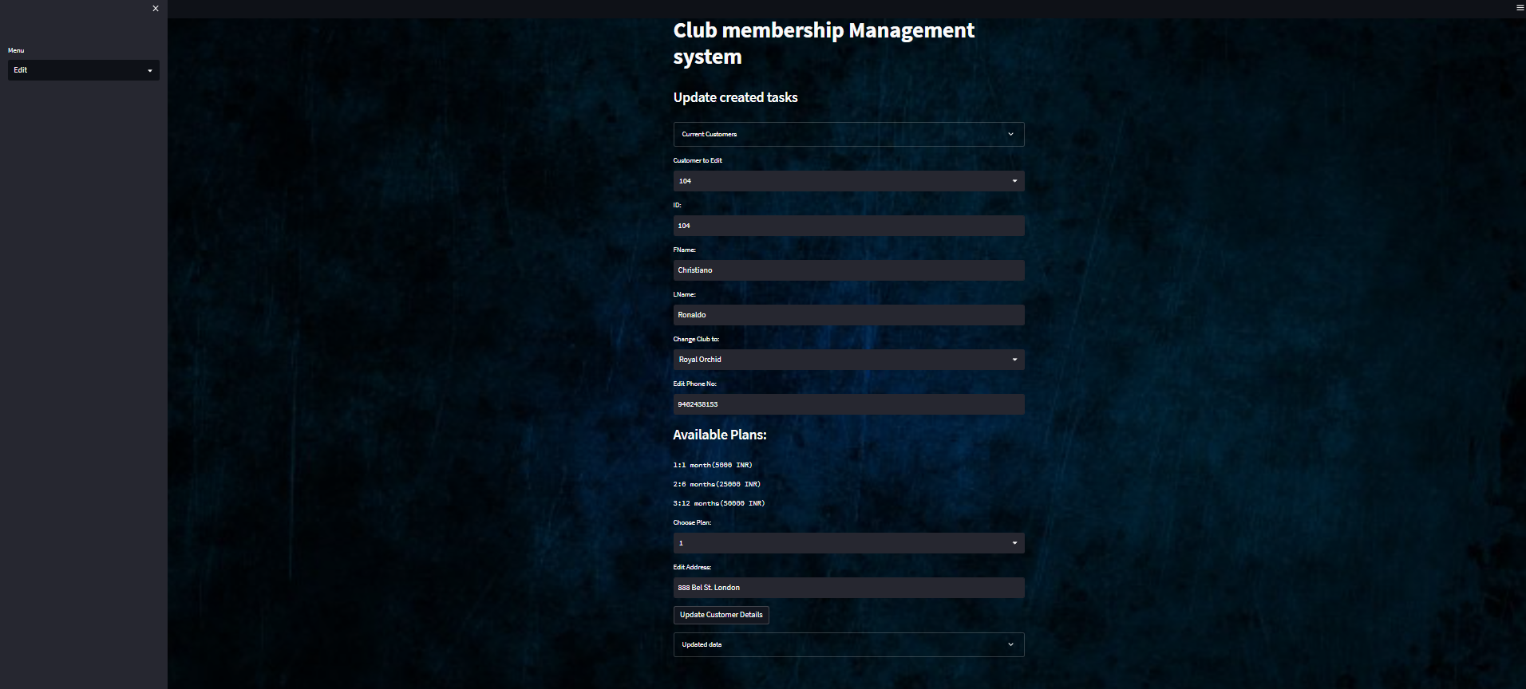

1. 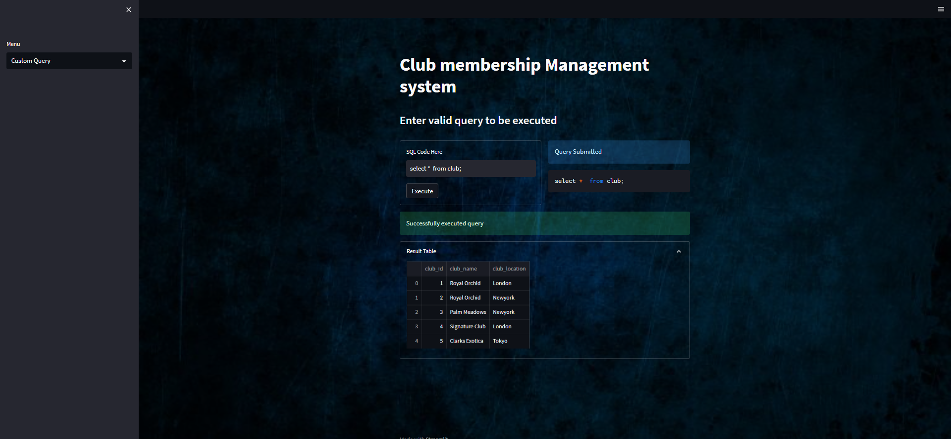Custom Query: